1. Design NFA to accept any number of b’s where input={a,b}.

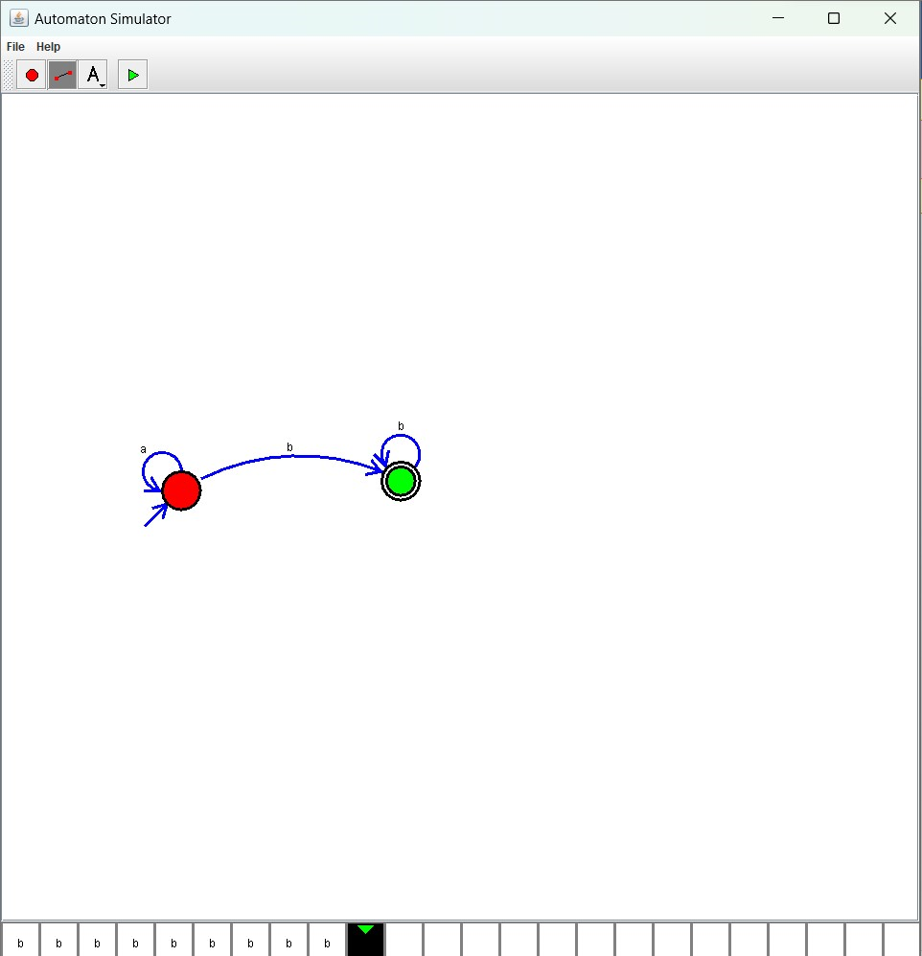  
  
Result:

The simulator is accepted the any number of b’s where input = {a,b} by using the above NFA diagram